Full Stack Development with MERN Project Documentation format

Introduction
  - Project Title: Househunt: finding your perfect rental home

  - Team members :

    - Polakomma Sravani[Designer]

    - Pendem Charan[Frontend]

    - Nandamuri Venkata Naga Sai Umadevi[Backend]

    - Pallavi Nagaraju[Designer]

Project Overview
HouseHunt offers a variety of features designed to enhance the real estate experience for buyers, sellers, renters, and professionals. These features aim to simplify property searches, provide valuable insights, and streamline the transaction process. Below are some of the key features of HouseHunt:
1. Advanced Property Search
- Filters: Users can filter properties based on location, price range, property type, size, number of bedrooms, and specific amenities (e.g., pet-friendly, pool, garage).
- Saved Searches: Allows users to save their search criteria for easy access to new listings that match their preferences.
2. Interactive Property Listings
- High-Quality Photos & Videos: Properties are showcased with professional images and video tours to give users a detailed view of the home.
- 360° Virtual Tours: Users can take interactive virtual tours of properties to get a feel for the space before scheduling an in-person visit.
- Floor Plans: Many listings include detailed floor plans to help users visualize the layout of a property.
3. Market Insights and Trends
- Price Trends: Displays information on how property prices are trending in specific areas, allowing buyers and sellers to make informed decisions.
- Neighbourhood Insights: Information on local amenities, schools, crime rates, and transport options, giving users a deeper understanding of the area they are considering.
- Investment Potential: Provides data on property value appreciation and investment opportunities for users looking to invest in real estate.
4. Property Alerts
- New Listings Alerts: Users can set up email or push notifications to be alerted when new properties matching their criteria are listed.
- Price Drop Alerts: Users are notified when a property they are interested in has a price reduction.

5. Professional Connection
- Real Estate Agents and Brokers: HouseHunt connects users with certified real estate professionals who can guide them through the buying, selling, or renting process.
- Legal and Financial Experts: The platform offers connections to legal advisors, mortgage brokers, and financial planners to assist with the paperwork and financial aspects of the transaction.

Architecture

Technical architecture
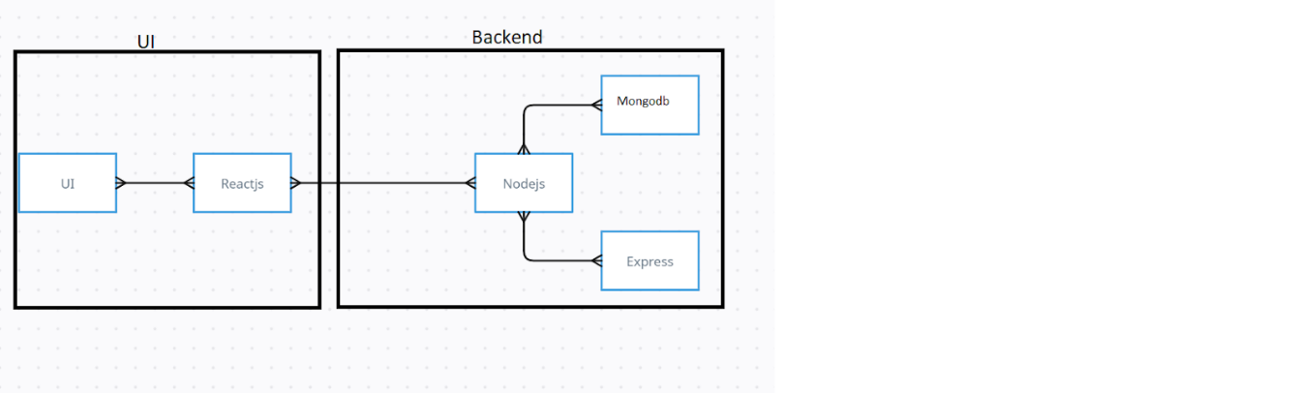

The technical architecture of our House rent app follows a client-server model, where the frontend serves as the client and the backend acts as the server. The frontend encompasses not only the user interface and presentation but also incorporates the axios library to connect with backend easily by using RESTful Apis.

The frontend utilizes the bootstrap and material UI library to establish real-time and better UI experience for any user whether it is admin, doctor and ordinary user working on it.

On the backend side, we employ Express.js frameworks to handle the server-side logic and communication.

For data storage and retrieval, our backend relies on MongoDB. MongoDB allows for efficient and scalable storage of user data, including user profiles, for booking room, and adding room, etc. It ensures reliable and quick access to the necessary information.

Together, the frontend and backend components, along with moment, Express.js, and MongoDB, form a comprehensive technical architecture for our House rent app. This architecture enables real-time communication, efficient data exchange, and seamless integration, ensuring a smooth and immersive booking an appointment and many more experience for all users.

ER DIAGRAM

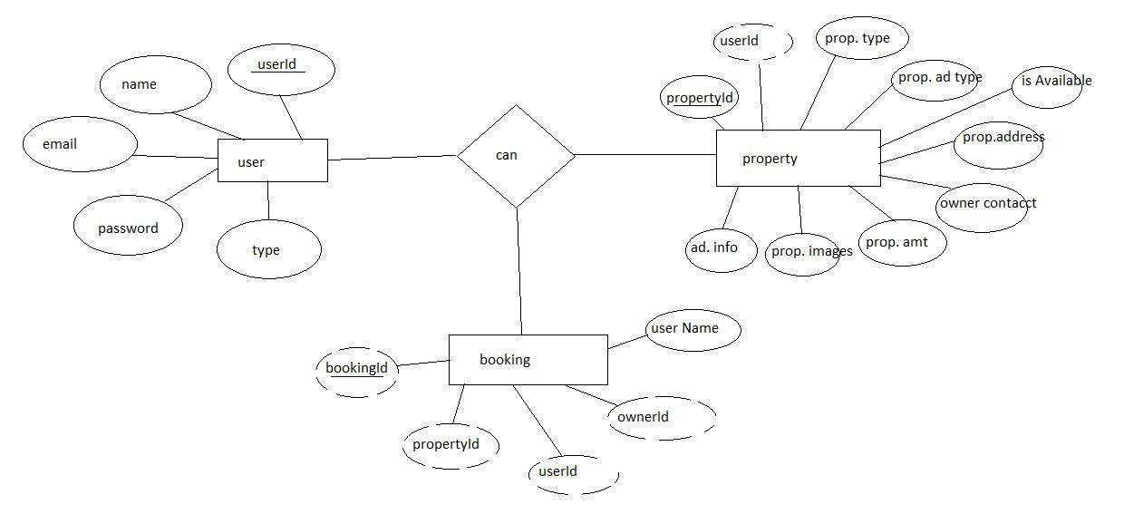

4.Setup Instructions

Here are the key prerequisites for developing a full-stack application using Node.js, Express.js, MongoDB, React.js:

✔Node.js and npm:

Node.js is a powerful JavaScript runtime environment that allows you to run JavaScript code on the server-side. It provides a scalable and efficient platform for building network applications.

Install Node.js and npm on your development machine, as they are required to run JavaScript on the server-side.

Download: https://nodejs.org/en/download/

Installation instructions: https://nodejs.org/en/download/package-manager/

npm init

✔Express.js:

Express.js is a fast and minimalist web application framework for Node.js. It simplifies the process of creating robust APIs and web applications, offering features like routing, middleware support, and modular architecture.

Install Express.js, a web application framework for Node.js, which handles server-side routing, middleware, and API development.

Installation: Open your command prompt or terminal and run the following command:

npm install express

✔MongoDB:

MongoDB is a flexible and scalable NoSQL database that stores data in a JSON-like format. It provides high performance, horizontal scalability, and seamless integration with Node.js, making it ideal for handling large amounts of structured and unstructured data.

Set up a MongoDB database to store your application's data.

Download: https://www.mongodb.com/try/download/community

Installation instructions: https://docs.mongodb.com/manual/installation/

✔Moment.js:

Moment Js is a JavaScript package that makes it simple to parse, validate, manipulate, and display date/time in JavaScript. Moment. js allows you to display dates in a human-readable format based on your location. Install React.js, a JavaScript library for building user interfaces.

Follow the installation guide: https://momentjs.com/

✔React.js:

React.js is a popular JavaScript library for building user interfaces. It enables developers to create interactive and reusable UI components, making it easier to build dynamic and responsive web applications.

Install React.js, a JavaScript library for building user interfaces.

Follow the installation guide: https://reactjs.org/docs/create-a-new-react-app.html

✔Antd:

Ant Design is a React. js UI library that contains easy-to-use components that are useful for building interactive user interfaces. It is very easy to use as well as integrate. It is one of the smart options to design web applications using react.

Follow the installation guide: https://ant.design/docs/react/introduce

✔HTML, CSS, and JavaScript: Basic knowledge of HTML for creating the structure of your app, CSS for styling, and JavaScript for client-side interactivity is essential.

✔Database Connectivity: Use a MongoDB driver or an Object-Document Mapping (ODM) library like Mongoose to connect your Node.js server with the MongoDB database and perform CRUD (Create, Read, Update, Delete) operations. To Connect the Database with Node JS go through the below provided link:

https://www.section.io/engineering-education/nodejs- mongoosejs-mongodb/

✔Front-end Framework: Utilize Reactjs to build the user-facing part of the application, including entering the booking room, status of the booking, and user interfaces for the admin dashboard.

For making better UI we have also used some libraries like material UI and bootstrap.

✔Version Control: Use Git for version control, enabling collaboration and tracking changes throughout the development process. Platforms like GitHub or Bitbucket can host your repository.

Git: Download and installation instructions can be found at: https://git-scm.com/downloads

✔Development Environment: Choose a code editor or Integrated Development Environment (IDE) that suits your preferences, such as Visual Studio Code, Sublime Text, or WebStorm.

• Visual Studio Code: Download from https://code.visualstudio.com/download

To run the existing Video Conference App project downloaded from GitHub:

Follow below steps:

Clone the Repository:

Open your terminal or command prompt.

Navigate to the directory where you want to store the e-commerce app.

Execute the following command to clone the repository:

git clone: https://github.com/awdhesh-student/house-rent.git

Install Dependencies:

• Navigate into the cloned repository directory:

cd house-rent

• Install the required dependencies by running the following commands:

cd frontend

npm install

cd ../backend

npm install

Start the Development Server:

• To start the development server, execute the following command:

npm start

• The house rent app will be accessible at http://localhost:3000

You have successfully installed and set up the online complaint registration and management app on your local machine. You can now proceed with further customization, development, and testing as needed.

5.Folder Structure
Client (React Frontend):
- Components:
- Reusable UI components (e.g., buttons, forms, cards)
- Page-level components (e.g., home, about, dashboard)
- Containers:
- Wrap components with logic and state management
- Handle data fetching and API interactions
- Services:
- API clients for interacting with the backend
- Utility functions for data processing and formatting
- State Management:
- Redux or MobX for global state management
- Local state management using React hooks
- Routing:
- Client-side routing using React Router
- Route protection and authentication

Server (Node.js Backend):
- Controllers:
- Handle incoming requests and send responses
- Validate user input and authenticate requests
- Models:
- Define database schema and interact with the database
- Use ORM (Object-Relational Mapping) tools like Mongoose or Sequelize
- Services:
- Business logic and complex operations
- Interact with models and external services
- Routes:
- Define API endpoints and HTTP methods
- Use middleware for authentication and rate limiting
- Middleware:
- Authenticate and authorize requests
- Handle errors and logging
- Database:
- MongoDB or other NoSQL databases
- Use database indexing and caching for performance

6.Running the Application
Frontend (Client):
1. Navigate to the client directory: cd client
2. Start the frontend server: npm start

Backend (Server):
1. Navigate to the server directory: cd server
2. Start the backend server: npm start

7.API Documentation

The project has 2 types of users – Renter and Owner and the other will be Admin which takes care of all the users. The roles and responsibilities of these two types of users can be inferred from the API endpoints defined in the code. Here is a summary:

Renter/Tenant:

Create an account and log in to the system using their email and password.

They will be shown automatically all the properties in their dashboard.

After clicking on the Get Info, all the information of the property and owner will come and a small form will be generated in which the renter needs to send his\her details.

After that they can see their booking in the booking section where the status of booking will be showing “pending”. It will be changed by the owner of the property.

Admin:

He/she can approve the user as “owner” for the legit user to add properties in his app

He monitors the applicant of all doctors and approves them and then doctors are registered in the app.

Implement and enforce platform policies, terms of service, and privacy regulations.

Owner:

Gets the approval from the admin for his Owner account.

After approval, he/she can do all CRUD operation of the property in his/her account

He/she can change the status and availability of the property.

8.Authentication

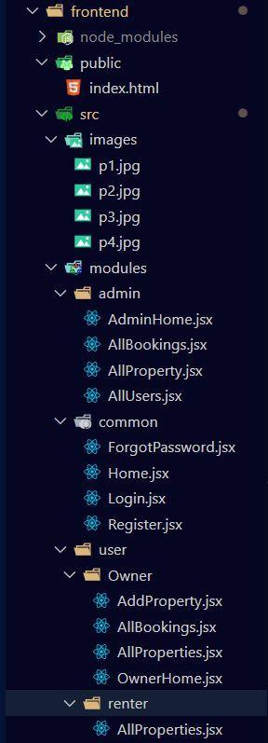
Authentication:
- JSON Web Tokens (JWT): Used for authentication, JWT tokens are generated upon successful login and verified on each subsequent request.
- Login Endpoint: Users provide credentials (username/password) to obtain a JWT token.
- Token Validation: Tokens are validated on each request using a middleware function.

Authorization:
- Role-Based Access Control (RBAC): Users are assigned roles (e.g., admin, user) that determine their access level.
- Protected Routes: Certain routes are protected by middleware functions that verify the user's role and token validity.

Token Management:
- Token Generation: Tokens are generated using a secret key and contain user information (e.g., ID, role).
- Token Verification: Tokens are verified on each request using the same secret key.

Session Management:
- Stateless Authentication: No sessions are stored on the server; each request contains the necessary authentication information.

Security Measures:
- HTTPS: Encrypted communication between client and server.
- Password Hashing: Passwords are hashed and stored securely using a library like bcrypt.

9.User Interface

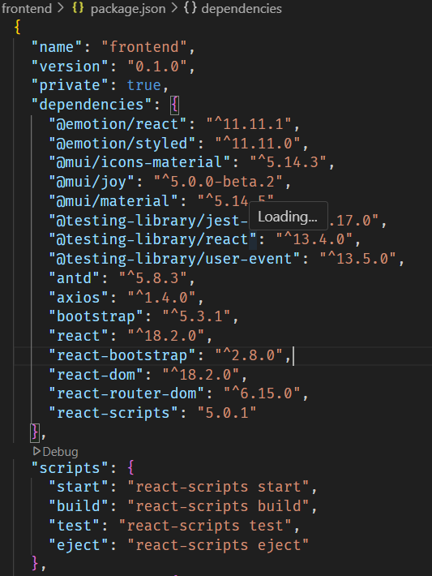
After the installation of all the libraries, the package.json files for the backend looks like the one mentioned below.
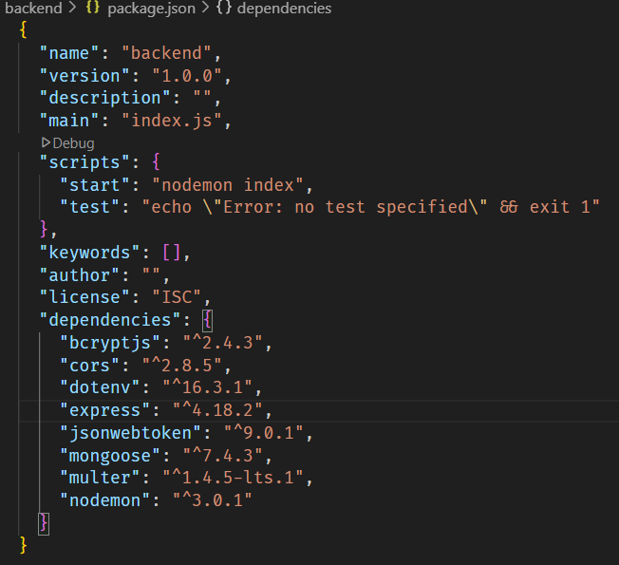

10.Testing
- Setup express server
- Create index.js file in the server (backend folder).
- define port number, mongodb connection string and JWT key in env file to access it.
- Configure the server by adding cors, body-parser.

- Configure MongoDB
- Import mongoose.
- Add database connection from config.js file present in config folder
- Create a model folder to store all the DB schemas like renter, owner and booking, properties schemas.

- Add authentication: for this,
You need to make a middleware folder and in that make authMiddleware.js file for the authentication of the projects and can use it.

Milestone 3: Database Development:
- Set up a MongoDB database either locally or using a cloud-based MongoDB service like MongoDB Atlas.
- Create a database and define the necessary collections for users, transactions, stocks and orders.
- Also let’s see the detailed description for the schemas used in the database.
- For the connection of database use the code given below
- 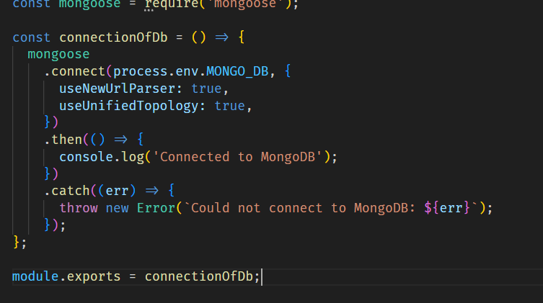
Milestone 4: Frontend Development:
- Setup React Application:
Bringing SB Stocks to life involves a three-step development process. First, a solid foundation is built using React.js. This includes creating the initial application structure, installing necessary libraries, and organizing the project files for efficient development. Next, the user interface (UI) comes to life. To start the development process for the frontend, follow the below steps.
- Install required libraries.
- Create the structure directories.
- Design UI components:
Reusable components will be created for all the interactive elements you'll see on screen, from stock listings and charts to buttons and user profiles. Next, we'll implement a layout and styling scheme to define the overall look and feel of the application. This ensures a visually-appealing and intuitive interface. Finally, a navigation system will be integrated, allowing you to effortlessly explore different sections of SB Stocks, like viewing specific stocks or managing your virtual portfolio.
- Implement frontend logic:
In the final leg of the frontend development, we'll bridge the gap between the visual interface and the underlying data. It involves the below stages.
- Integration with API endpoints.
- Implement data binding.

11.Screenshots or Demo

Register or Sign Up:

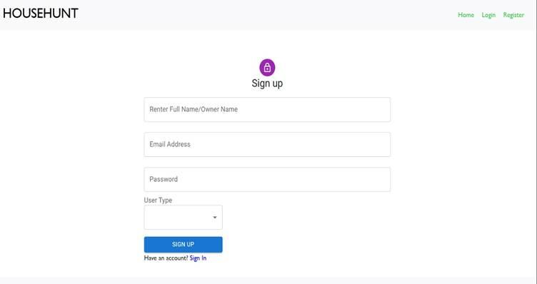

Login:

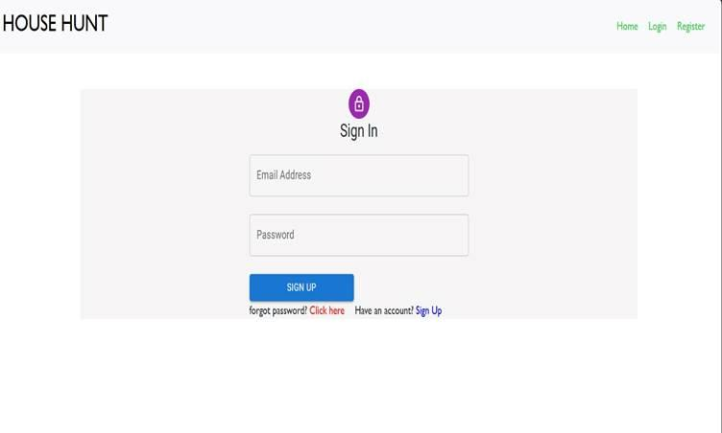

Properties:

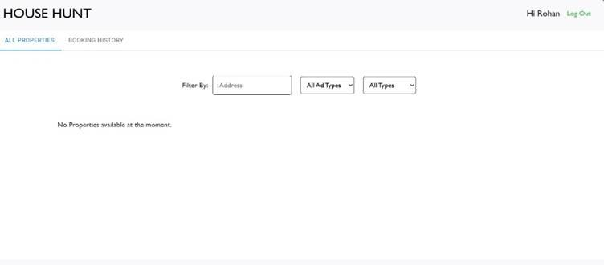

Booking History:

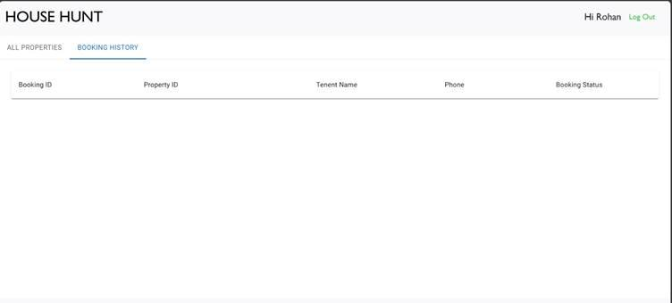

12.Known Issues

Known Bugs or Issues:

Frontend:

1. Intermittent Loading Issues: Some users may experience intermittent loading issues when navigating between pages.

2. Form Validation Errors: Form validation errors may not be displayed correctly in certain cases.

Backend:

1. Rate Limiting: The backend may return a 429 error if the rate limit is exceeded. Users should wait a few seconds before retrying.

2. Database Connection Issues: In rare cases, database connection issues may occur, resulting in errors.

General:

1. Browser Compatibility: The application may not be fully compatible with older browser versions.

2. Performance Issues: Performance issues may occur with large datasets or complex queries.

Workarounds:

1. Refresh the Page: Refreshing the page may resolve intermittent loading issues.

2. Check Server Status: Check the server status to ensure it's operational.

Future Fixes:

These issues are being addressed in future updates. Users and developers can expect fixes and improvements in upcoming releases.

13.Future Enhancements
  - potential Future Features:
  - Frontend:
  - 1. Enhanced User Profile Management: Allow users to customize their profiles with more information and preferences.
  - 2. Advanced Search Filters: Add more search filters to help users find properties that match their specific needs.
  - 3. Interactive Property Comparison: Enable users to compare multiple properties side-by-side.

  - Backend:
  - 1. Integration with More Data Sources: Integrate with more data sources to provide a wider range of properties and information.
  - 2. Improved Search Algorithm: Develop a more sophisticated search algorithm to provide more accurate and relevant results.
  - 3. Automated Property Updates: Automate property updates to ensure that users have access to the most up-to-date information.

  - General:
  - 1. Mobile App Development: Develop a mobile app to provide users with a more convenient and accessible way to find properties.
  - 2. Machine Learning Integration: Integrate machine learning algorithms to provide users with personalized property recommendations.
  - 3. Enhanced Security Measures: Implement additional security measures to protect user data and prevent unauthorized access.

  - Potential Improvements:
  - 1. Performance Optimization: Optimize the application's performance to provide faster load times and improved responsiveness.
  - 2. User Experience Enhancements: Make user experience enhancements to improve the overall usability and accessibility of the application.
  - 3. Scalability Improvements: Implement scalability improvements to ensure that the application can handle increased traffic and user growth.

  - These are just a few potential future features and improvements that could be made to the project. The specific features and improvements will depend on user feedback, business goals, and technical feasibility..

